Math 1Name_______________________________

**7-2 Practice** Date________

1. In the 2007 NBA Playoffs LeBron James played in 20 games. His points scored during the 2007 NBA Playoffs are as follows:

**23, 27, 30, 31, 21, 36, 18, 30, 20, 23, 10, 19, 32, 25, 48, 20, 14, 25, 25, 24**

a. Use your calculator to find the five-number summary**.**

b. Use the five number summary to algebraically calculate any outliers.

**SHOW ALL WORK**

c. Find LeBron’s average points per game in the 2007 NBA Playoffs.

2. The data below are the grades out of 50 from a test given earlier this year. Create a histogram below.

31, 29, 27, 21, 29, 32, 18, 30, 32, 23, 26, 30, 27, 27, 33, 33, 25, 21, 25, 25, 32, 31, 35, 30, 28, 31, 21, 32

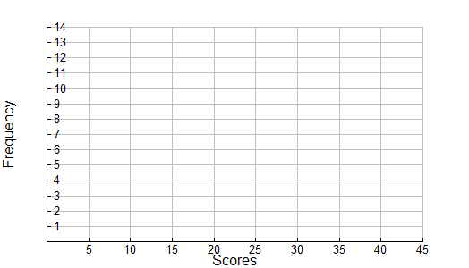

Describe the distribution (remember the four parts...SOCS).

1. In the 2007 NBA Playoffs Zydrunas Ilgauskasplayed in 20 games. His points scored during the 2007 NBA Playoffs are as follows:

**16, 16, 24, 20, 8, 13, 11, 13, 16, 6, 22, 3, 16, 9, 16, 11, 2, 9, 12, 8**

a . Use your calculator to find the five-number summary**.**

b. Use the five number summary to algebraically calculate any outliers.

**SHOW ALL WORK**

c. Find Z’s average points per game in the 2007 NBA Playoffs.

d. Create 2 box plots for the points scored by LeBron and Zydrunas in the 2007 NBA Playoffs.



e. Describe the distributions of the box and whisker plots that you created above.

1. According to the statistics, which basketball player would be better to have on a team? Support your answer with statistics.